The CARE Clinic is livening up the grounds with a brand-new meditation garden! For nearly 30 years the clinic has stood as a staple of health, education, and commitment right here on Robeson Street. Now, it is time to bring new life to the property.

As a nonprofit, The CARE Clinic receives no government funding. Instead, we rely solely on donations, grants, and fundraising efforts such as this one to cover the nearly $55,000 in operational costs incurred each month. Our mission is to provide free, quality healthcare with Compassion, Assistance, Referral, and Education for the uninsured, low-income adults in our community. The need for our services has greatly increased as the pandemic has affected many. Please consider helping out and participating in this wonderful opportunity.

If you have any questions, please contact:

development@thecareclinic.org
or (910) 485-0555

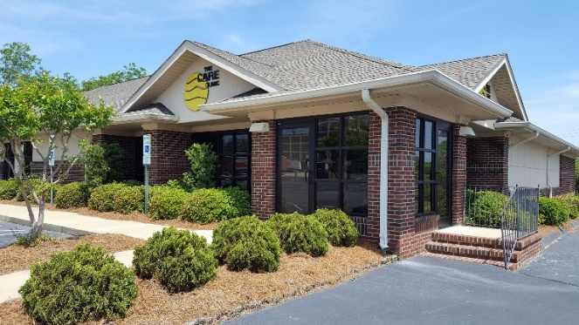
Donor Information

Name____________________________
Address__________________________ Address__________________________
City,State_________________________
Zip Code__________________________
Email____________________________
Phone____________________________
Donation Amount ($)_______________
Clip Art Selection__________________
Make Check Payable to:
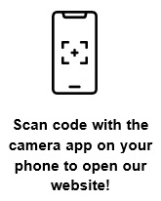
The CARE Clinic
P.O. Box 53438
Fayetteville, NC 28305

Number of Bricks | Price Text Only (each) | Price with Clip Art (each)
1 | $100 | $110
2 | $90 | $100
3 | $80 | $90
4 | $70 | $80
5 | $60 | $70
Replica Tile (same text as your brick) $15.00

Engraved Brick
Fundraiser

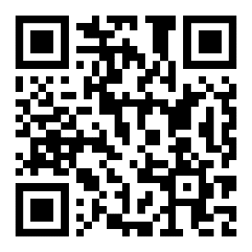

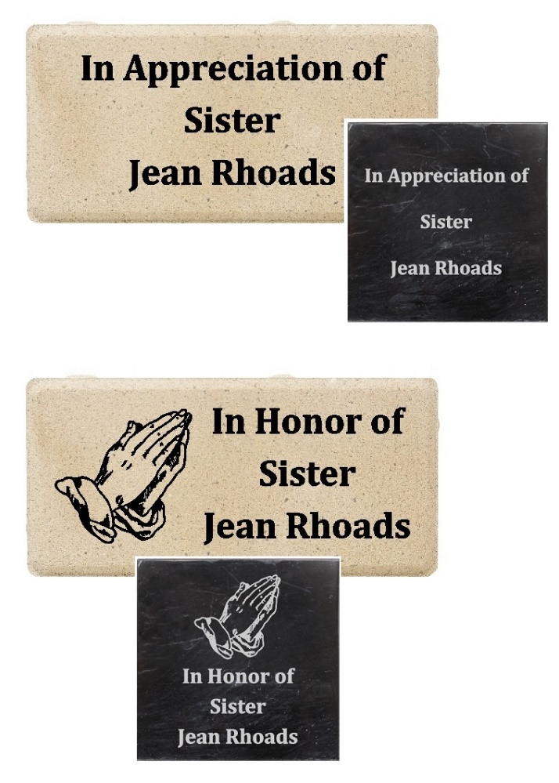

Clip Art Section:
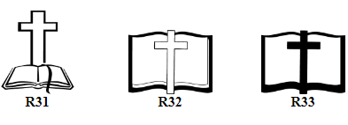
To view our full clip art library, please visit:
https://polarengraving.com/thecareclinic

OR Scan the QR Code at the front!

4" x 8" Engraved Brick
Please do not write in shaded area if you are getting clip art on your brick
If you would like multiple bricks, please use additional bricks below.
